# ITC Mid Term Fall2020 – X1

**Instructions:**

* Write down answer of each question here (you can use compiler to run code but you have to paste code or answer in given box)
* Time limit is 35 **mints** and **5 mints** are for uploading
* There are total 2 questions

_______________________________________________________________________________

**Question # 1: Marks [10]**

Implement following flow chart in C++.

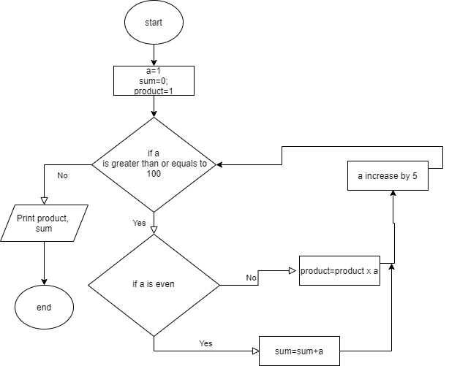

|  |
| --- |
| #include<iostream>  using namespace std;  int main()  {  int a=0;  int sum=0;  int product=0;  while(a>=100)  {  if(a%2==0)  {  sum=sum+a;  }  else  {  product=product*a;  }  a=a+5;  }  cout<<product<<sum<<endl;  } |

**Question # 2: Marks [10]**

**Dry run the given code and maintain an iteration table, to show the value of each variable in each iteration.**

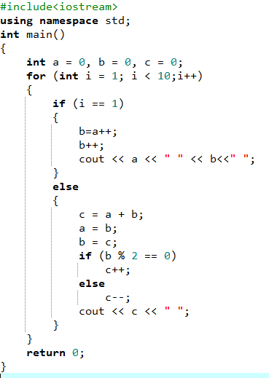

**// complete iteration table given below. If you need extra rows, please insert them**

|  |  |  |  |  |  |
| --- | --- | --- | --- | --- | --- |
| **Iteration #** | **a** | **b** | **c** | **i** | **Console output** |
|  | 0 | 0 | 0 |  |  |
| **1** | **1** | **1** | **0** | **2** | **1 1** |
| **2** | **1** | **2** | **3** | **3** | **1 1 3** |
| **3** | **2** | **3** | **2** | **4** | **1 1 3 2** |
| **4** | **3** | **5** | **4** | **5** | **1 1 3 2 4** |
| **5** | **5** | **8** | **9** | **6** | **1 1 3 2 4 9** |
| **6** | **8** | **13** | **12** | **7** | **1 1 3 2 4 9 12** |
| **7** | **13** | **21** | **20** | **8** | **1 1 3 2 4 9 12 20** |
| **8** | **21** | **34** | **35** | **9** | **1 1 3 2 4 9 12 20 35** |
| **9** | **34** | **55** | **54** | **10** | **1 1 3 2 4 9 12 20 35 54** |
|  |  |  |  |  |  |
|  |  |  |  |  |  |
|  |  |  |  |  |  |